# **README - General- Installer & Application**

# **Smart Class Planning Tool**

## **Purpose**

This document serves as a guide for the Smart Class Planning Tool to help users understand, install, and operate the application. It provides an overview of the tool’s purpose, key features, and functionality. It provides step-by-step instructions for setup and usage. Additionally, it outlines system requirements and prerequisites, dependencies, and other tips to ensure a smooth experience for users.

The Smart Class Planning Tool itself is an application designed to streamline academic advising by generating personalized course plans. It integrates data from DegreeWorks PDF, Graduate Study Plans, a 4-year course schedule, and website prerequisite information. The tool analyzes all this information to recommend an optimized class plan in Excel format. It is a user-friendly tool that supports academic advisors and students in making efficient, informed decisions about course selection and planning.

## **Prerequisites**

## System Requirements:

## Operating System: Windows 10 or later

## RAM: At least 4 GB

## Disk Space: Minimum 500 MB free

## Data Requirements:

## Input Files:

## DegreeWorks PDF

## Graduate Study Plan (in specified format)

## 4-year course schedule (CSV or Excel)

## Internet Access:

## Required for fetching prerequisite data from the course website.

## 

## **Download**

To get the Smart Class Planning Tool, download the recent release from: <https://github.com/ddCode1935/Planning-Tool>

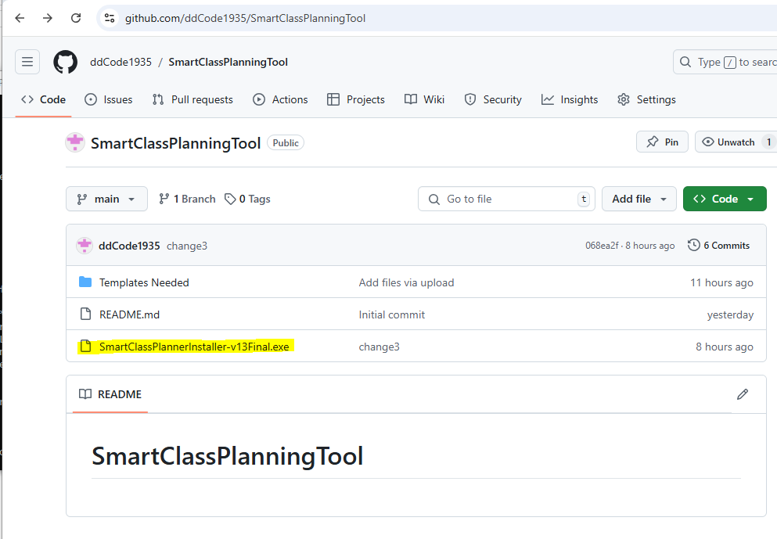

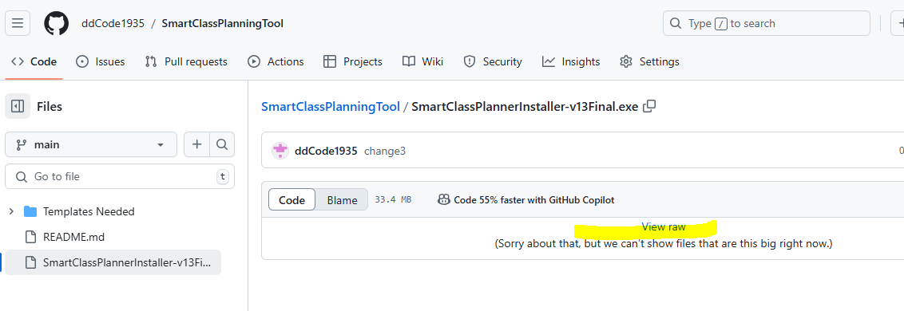

## **Build/Configuration/Installation/Deployment**

**Build:**

The file that will be downloaded to the Downloads folder will have .exe for an application and should look such as below. It is a small application file at a size of 33.3 MB. It has all the information needed to install the final application.

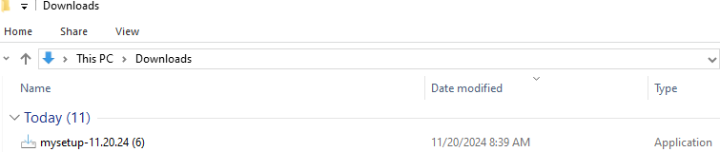

**Configuration:**

The file requires minimal configuration and is designed to work seamlessly in Windows once installed. The application runs as a standalone executable, meaning no Python installation or manual dependency management is required. After installation, no additional setup is needed. The application detects the required input files (DegreeWorks PDFs, Graduate Study Plans, and the 4-year course schedule) once the path of the designated input folder is given.

**Installation:**The Smart Class Planner can be installed quickly and easily using the provided installer. The process is streamlined to ensure a smooth experience.Below are few screenshots for using the installer:

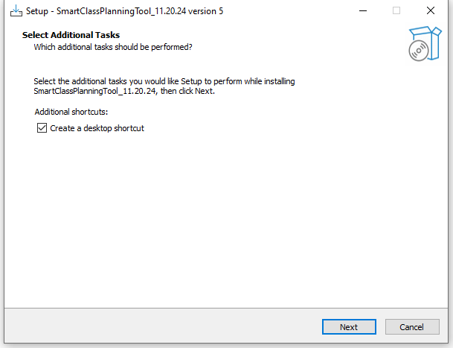

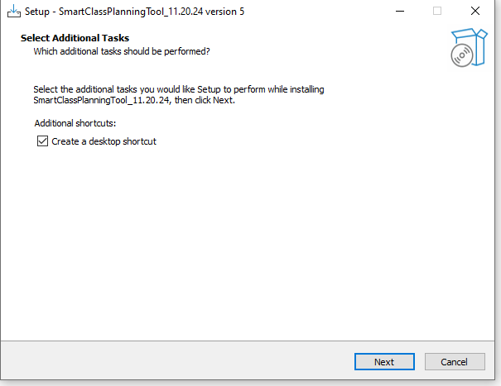

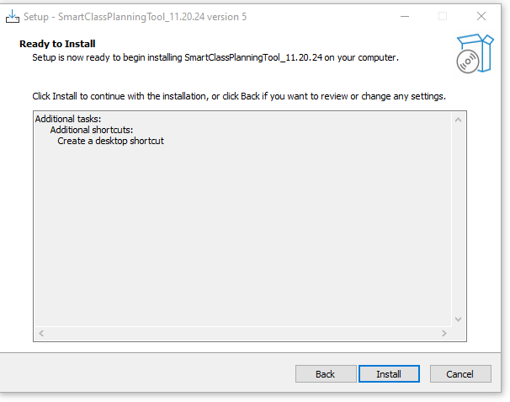

**Deployment:**

After the installer completes, the SmartClassPlanningTool app gets created. It just needs to be open and then a list of questions will appear. As an example, the desktop app is being added to following path of this computer: C:\ProgramData\Microsoft\Windows\Start Menu\Programs

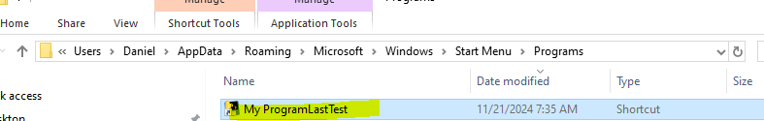

It should also appear in the start screen.

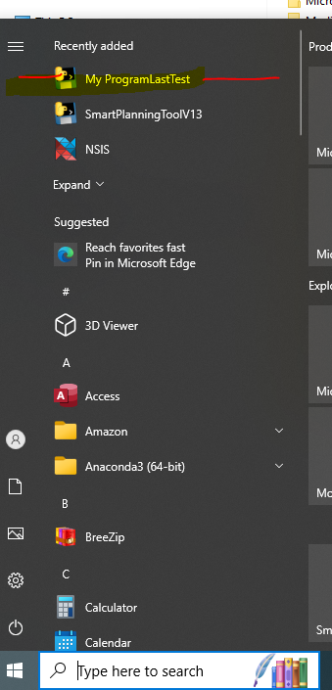

**Other Input Files:**

Templates for uploading DataFrames are essential to ensure consistency and accuracy in data entry. They provide a structured format that minimizes errors, guiding users to include required fields and adhere to constraints. This not only improves user experience by simplifying data preparation but also enhances the reliability of data used by the smart class planning tool. A consistent format allows for efficient parsing and analysis, as the system can anticipate data in a predefined structure. A separate README file was created for the templates

## **Usage**

To start using the program, open it from the Start Menu or from Desktop.

A list of questions will appear in question and user input sequence back and forth until it reaches the end.

The first question asks for the path of the updated DegreeWorks document.

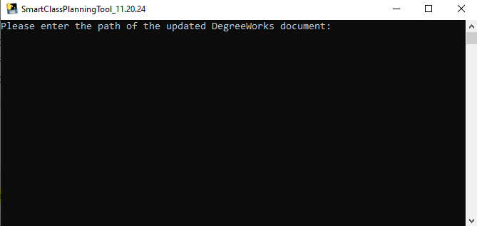

Series of questions are asked to the user and useful information is provided as user goes through the program

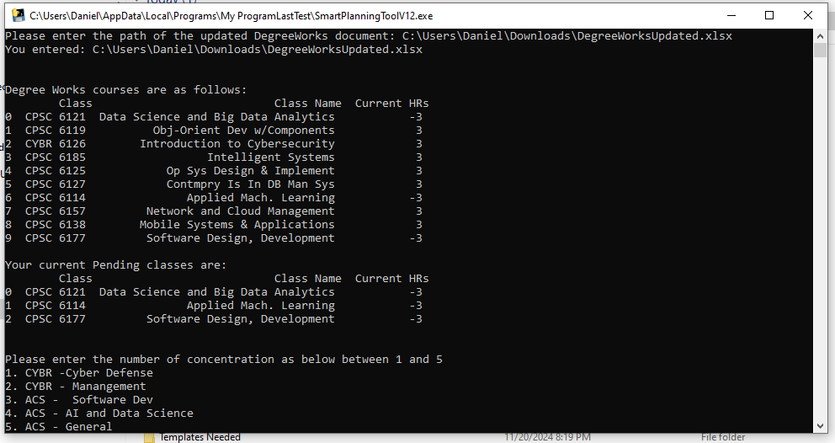

One of the last questions asks where to save the Excel file.

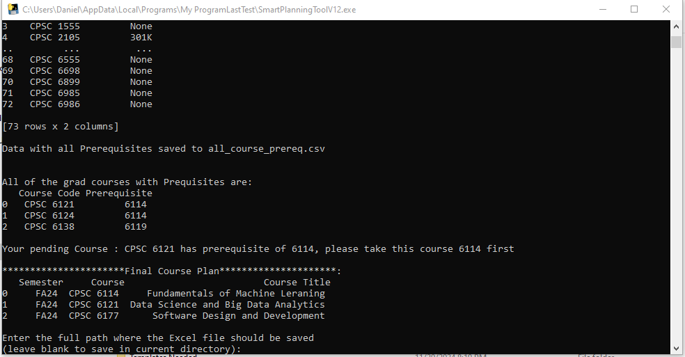

The last question is to press Enter by the user to exit the program. This allows the user to see useful inputs prior to exiting the program.

